

ATAR Physics

Year 12 2019

**Task 8:**

**Standard Model Research and Evaluation Assignment**

Student Name: ______________________

I acknowledge that all the information contained in this task is my own work and not taken from other sources. If other sources have been used they have been acknowledged in my references.

____________________________________

(Student Signature)

Teacher Comments:

|  |  |
| --- | --- |
| **Weighting: 5% of year** | **Due Date:** |
| **Marks:** Research Notes **10%** Validation test **90%** | |

The following Web Quest / research will be completed regarding the “Standard Model”. You will be assessed mostly on the basis of a validation assessment (test) which will be conducted on the due date. You will be allowed to complete the assessment with the aid of the research notes made on the questions below. A smaller portion of your marks will be based on the quality of your research notes which will also be submitted on the day of the assessment.

**Research notes are to be:**

1. summarised dot point form only.
2. printed or hand written.
3. in your own words. (not cut and pasted) – This will be a factor in marking.
4. may include hand drawn diagrams where appropriate, but not printed diagrams.

**Background**

The Standard Model of particle physics is a theory concerning the forces and particles that make up the universe. It describes the electromagnetic, weak, and strong nuclear interactions, as well as classifying all the subatomic particles known. It was developed throughout the latter half of the 20th century, as a collaborative effort of scientists around the world.

**Task**

Visit the link to The Particle Adventure provided for each section and answer the questions. Use the blue arrows at the top of the page near the “HOME” button to scroll through the screens. Be sure to read as you go along. The purpose of this activity is to reinforce the topic and enhance your understanding of key points. You may also need to **use your textbook** or other **internet resources** where you find it difficult to understand or find answers on this web page.

<http://www.particleadventure.org/standard-model.html>

<http://hyperphysics.phy-astr.gsu.edu/hbase/Particles/parint.html#c1>

**PART I.** [What is fundamental?](http://www.particleadventure.org/standard-model.html)

1. This section discusses what is meant by “fundamental” in terms of the constituents of matter.  Briefly describe the key ideas given in this section.
2. What are the three main components of the Standard Model?

**PART II.** [What is the world made of?](http://www.particleadventure.org/quarks_leptons.html)

1. How many types of quarks are there and what kind of charge do they have?
2. Explain the concept of antimatter.
3. How do we show that a particle is an antimatter variant in a reaction? E.g. Antineutrinos, anti up quarks, anti-muons etc …
4. 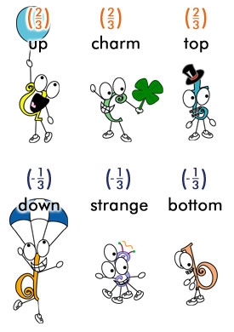Quarks exist in groups called hadrons. Describe the two types of hadrons and what kinds of particles do they form. Explain what is meant by the fact that only a very small part of the mass of a hadron is due to the quarks in it.
5. What differences are there between quarks and leptons?
6. How many leptons are there and which are their characteristics?
7. Explain why the muon and the tau, are not found in ordinary matter at all.
8. What are the special characteristics of neutrinos and what is their importance related to the expansion of the universe?
9. Draw a chart with the three generations of matter clearly labelled.
10. What are the major difference between generation I particles and similar particles in higher generations?
11. In the every-day world we observe only the first-generation particles in most natural situations. What happens to the higher generation particles?

**PART III.** [What holds it together?](http://www.particleadventure.org/4interactions.html)

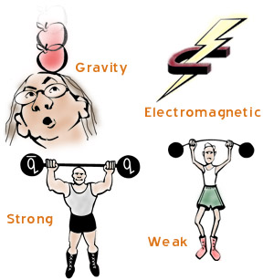

Some of the following questions are probably best answered using a table. You may need to use other resources here.

1. Name the four fundamental interactions between particles.
2. What is the difference between a force and an interaction?
3. Briefly explain what each of the four interactions/forces does.
4. Describe the relative strengths of these interactions.
5. Detail the relative range of effect involved with these forces.
6. What are the force carrier particles for these interactions?
7. What is the name given to a force carrier particle?
8. Explain what the colour charge is and how it is assigned to particles, antiparticles and gluons.

**PART III.**

[How do we detect what's happening?](http://www.particleadventure.org/detect_world.html)

1. Explain how physicists apply the concepts of momentum and wavelength to study particles.

**PART IV.**

[How do we experiment with tiny particles?](http://www.particleadventure.org/accel.html)

1. How does an accelerator work?
2. How do you obtain electrons, protons and antiparticles?
3. What are the types of collisions that can be produced in accelerators?
4. What is the difference between a linac and a synchrotron?
5. What are the main advantages of a circular accelerator over a linear accelerator?
6. Explain what is meant by an event.
7. To analyse the collisions of particles in an event scientists use detectors. Explain why detectors are shaped in different forms.
8. Modern detectors consist of different components. Explain what the purpose of having various components is.

**PART V.**

**This section is touched on briefly in the web page, under lepton decays and lepton conservation. Unfortunately it is probably presented in a way that is a little confusing and needs further research using other resources to understand fully.**

The Year 12 course has the following statement.

**“Lepton number and baryon number are examples of quantities that are conserved in all reactions between particles; these conservation laws can be used to support or invalidate proposed reactions”.**

1. Explain what we mean by Lepton and Baryon numbers.
2. Explain how we can use conservation laws with Lepton and Baryon numbers to support or invalidate a nuclear reaction equation that is presented to us.
3. Write out some examples of reactions to help you understand the process used to do the above.